



Data Structures & Algorithm
LAB MANUAL

Disclaimer: The content is curated from online/offline resources and used for educational purpose only
Inorder Traversal of Binary Tree

Objective:
To perform inorder traversal of a binary tree using recursion.

Equipment Required:
- Computer with Python installed, text editor/IDE.

Prerequisites:
- Understanding of trees, recursion, and class-based structure in Python.
Problem Statement:
Write a Python program to create a binary tree and display its inorder traversal.

Procedure:
- Define a class Node with left, right, and val.
- Create a binary tree manually.
- Implement inorder() function recursively.
- Print node values during the traversal.

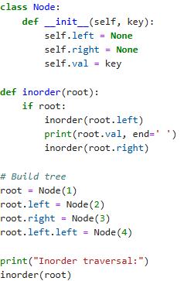

Output:
